A Sample Database

A system to help a newsagent keep track of newspaper deliveries and customer accounts. Details will be held on customers and newspapers.

The main objectives:

* Add, edit and delete details of customers, newspapers and deliveries
* Print a “round sheet” showing which newpapers are to be delivered to each customer on a given round each day

We are going to use three tables:

Delivery

Newspaper

Customer

One-t

Set up the Customer Table – Consider field size, data type and add a description. Use lookups, data validation, default values. Make a new field called TotalOwed and make it a calculated field.

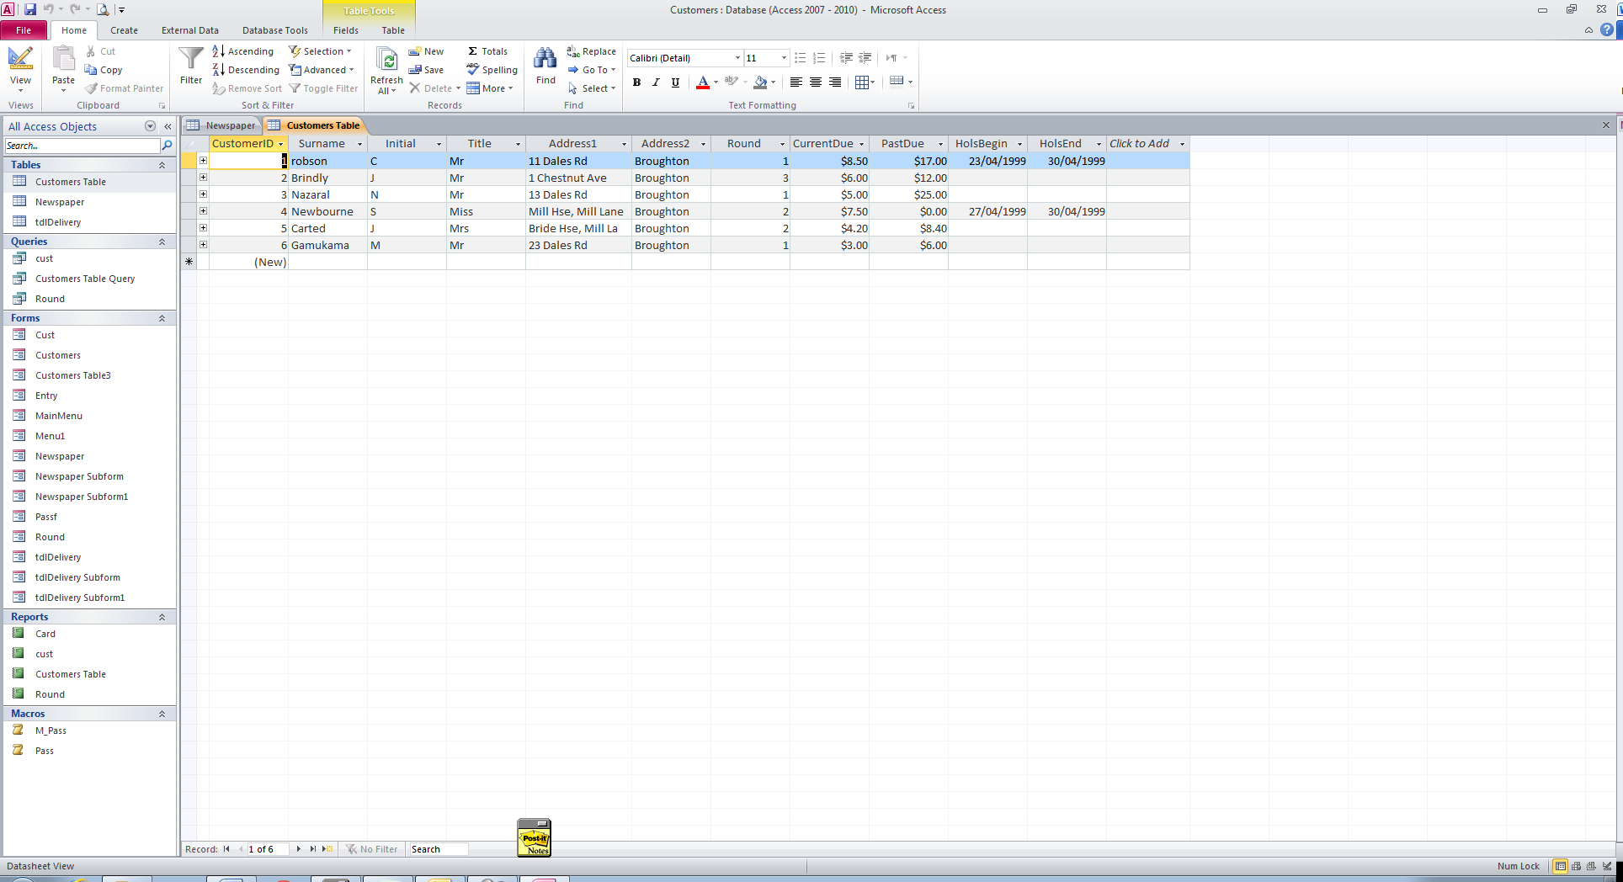

* 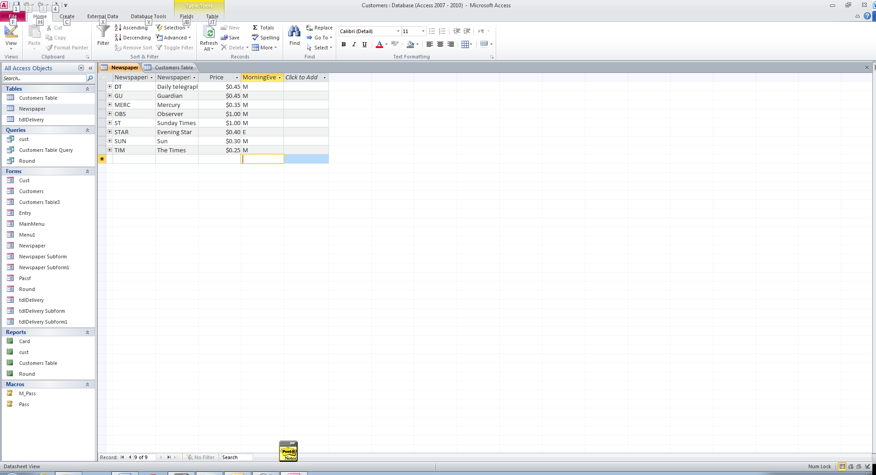Set up the Newspaper Table
* Set up the Delivery Table
  + The first 2 fields are lookups
  + 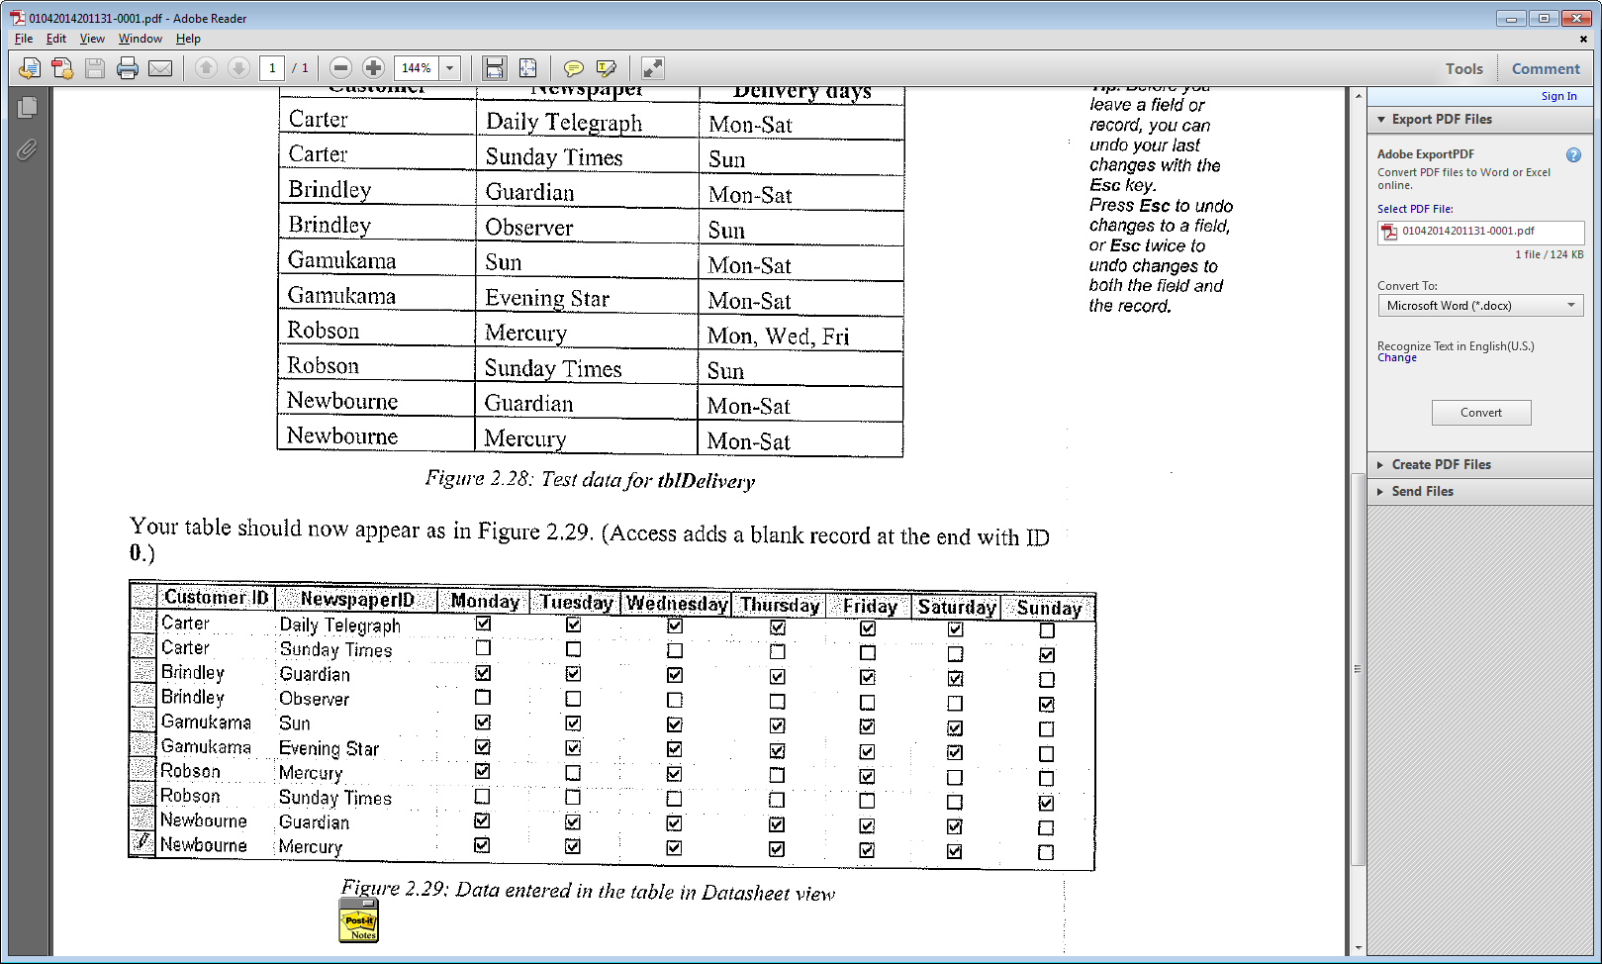The other fields are Yes/No fields

Forms

* Set up forms for each of the tables to make it easy to change the data
* Set up a separate form which allows people to change the holiday times only.
* Set up a form as a menu. Add links to the forms above and any other reports/ forms you make
* Set up a form to ask for a password (see notes on S drive - Access Tips)

Queries

Write queries to show:

1. Customers in round 1
2. Customers in a particular round (use [Which round] as criteria)
3. Customers who live in Dales Rd
4. Customers who live in a particular street.
5. Customers who have an entry in HolsBegin (use Not Null)
6. Customers who owe more than $20 in total
7. Customers who owe more than $x in total
8. Newspapers in order of price
9. Evening Newspapers

Reports

Write reports for the queries 2, 4, 5, 7, 8, 9

Membership Cards

It is desired to have a membership card which will display the person’s name, address, round number and ID number. Design the card (use a report) and a method of bringing up the card (by itself)

Delivery Printouts

Design a system to print out Delivery lists – ie all people who get papers delivered on Monday am, Tuesday pm etc. Sort these lists by Round and then by customer.

Removing Holidays

Design a system that removes the holiday information once the dates are past.

**New Table**

Design a system to remove a round from the database and make a new table for it.

Create a form to show a customer and the paper (s) that they get and the days on which they get them.

Write a report showing the totals owed by each of the 3 rounds. Show the customers and display them in order (within the rounds) of the amount they owe.

Create a report to print an invoice for how much a particular customer owes.

Write a letter to inform all round 1 customers that there will be an hours delay in their deliveries for the next three weeks.